Half Day Surveillance Workshop
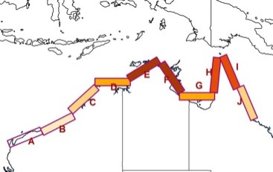
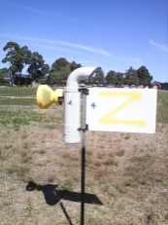
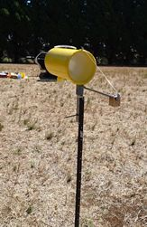
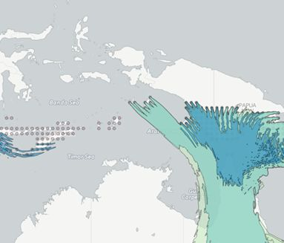
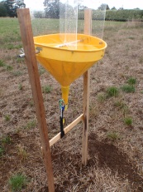
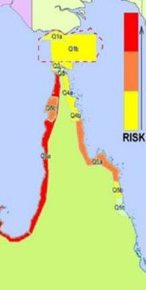

New Surveillance Strategies
for Wind Dispersed Pests and Diseases

When: Thursday 24 August 2017, 9.30-1.30

Where: NAQS, DAWR, Building 114, Catalina Crescent, Airport Business Park, Cairns Airport, Cairns, QLD 4870

We will discuss:
- The potential for pests and diseases to enter North Queensland by long distance wind dispersal
- New strategies for NAQS surveillance activities
- Demonstrations of alternative trapping techniques for surveillance
- New molecular tools for identifying exotic pests and diseases
- The new National Plant Surveillance Network
- An in-depth analysis of wind dispersed threats to SUGARCANE

This workshop is suitable for:
- NAQS and other surveillance staff
- Peak industry body representatives and extension staff
- Biosecurity Agencies
- Growers

Presented by:
John Weiss (DEDJTR), Kyla Finlay (DEDJTR), Mark Blackett (DEDJTR), Les Zeller (Univ Southern Queensland), Callum Fletcher (AUSVEG)

A light lunch will be provided

Please RSVP for catering purposes to Kyla Finlay, kyla.finlay@ecodev.vic.gov.au


